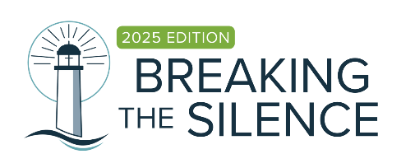

MEDICATION ADMINISTRATION PERMISSION FORM

By completing this Medication Administration Permission form, I provide authorization for approved leaders to administer prescribed medication.
A Child Registration form is completed prior to the use of this form Yes
This form will be reviewed at least annually or revised when any changes are made.

Permission (To be completed by parent)
I, ____________________ (parent/ guardian) authorise ________________________(name of program) of ___________________________ church to administer the following medication to my child ________________________ (child’s name).
Child’s surname: |  |  | Child’s first name:
Date of birth
Medication authority form is valid from: ___/___/_______ to ___/___/________
Medication (Name as shown on packaging):
Expiry date of the medication:____/___/______ |  |  | Prescribed dosage:
Times of day to be administered:
Reason for medication to be administered:

Storage or Special instructions (e.g. must be taken with food or with a glass or water):

I understand that PRESCRIPTION medication can only be given to my child if the medication is (please tick to confirm):
 | in its original packaging
 | Has a dispensing label showing the child‘s name and instructions for use
 | has a current use by date
I understand that NON-PRESCRIBED, homeopathic, herbal or naturopathic medication will only be administered if (please tick to confirm):
 | it is in a container with a label containing the child‘s name
 | the name of the medication is clear
 | there is a current use by date
 | there are instructions or a letter from a pharmacist or the registered health professional
Does your child require a Medical Management Plan?
 | Yes | No
 | Review date for Medication Administration form: _____/_____/_________
Please provide details of the medical management plan which include details, symptoms and triggers of medical condition and action or medication to administer.

Emergency Details
Emergency contact person/s: | Contact number/s:
Doctor’s name: | Doctor’s contact number:
Doctor’s address:
Privacy
Personal information collected is used only for purposes relating to the spiritual, pastoral, social, educational, administrative, legal and historical functions of the Church subject to the Church‘s Privacy Policy in accordance with the Privacy Amendment (Private Sector) Act 2000. Your acceptance of this written advice will be regarded as your consent to collect and so use the information as described. If you do not consent please advise immediately. A copy of the Church‘s Privacy Policy is available on the PCNSW website or upon request. Personal information will not be used for any other purpose without first obtaining your consent.

I agree that the information contained on this Medication Authority Form is true and correct.
I agree that I will ensure that any changes to this information are advised in writing as soon as possible.

Signature (parent and church representative to sign)
Parent / Guardian’s signature: | Date:
Parent / Guardian’s name (please print):
Representative of church’s signature: | Date:
Representative of church’s name (please print):

